Scrapbook Purpose

- A collection of content you’ve earned
- Promise of the content to come
- Shows game progression
- Easy Navigation
- Interactive where possible (ie. Not just show vehicles, also show damage of 3d models)

Structure

The Scrapbook works as a series of Volumes that relate to each level. The first page of each volume will have a title page that indicates all information presented in the pause menu. Within each level volume there will be a series of Chapters that break the level down into a consistent series of collectables.. Each Collectables chapter will illustrate what has been collected and what still remains to be collected. The chapter’s menu will look something like:

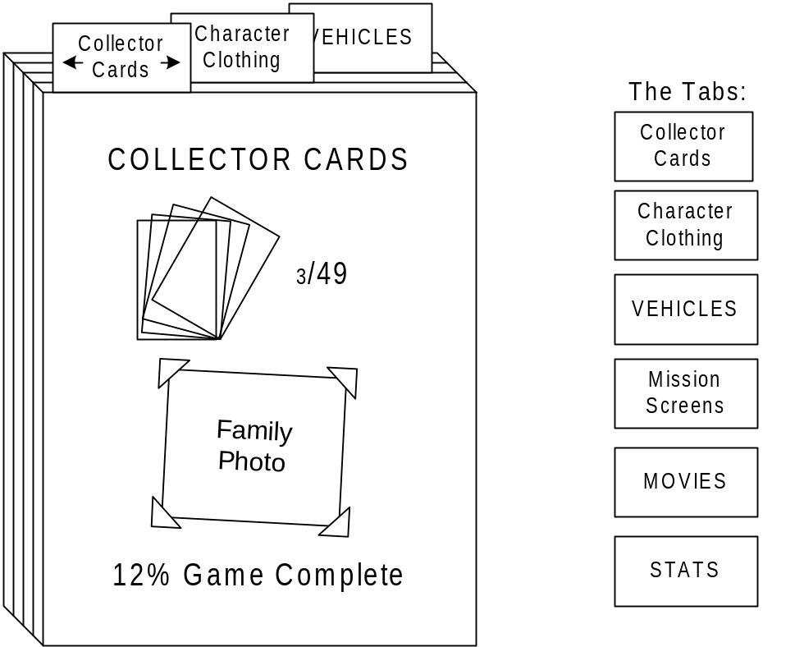

- Select the tabs with left/right arrows
- The front of the book shows:
  - An image representing the tab (e.g. a deck of cards for the collector cards)
  - Stats on how many you have and the total number available (e.g. above - 3 out of 49 cards collected)
  - A 2D family photo that changes every time you enter the scrapbook (new 2d content from Dallas)
  - % Game Complete – calculated solely in terms of the rewards you have earned, with each reward weighted equally
When you press X to select a category, an interface like the current Card Gallery is displayed:
- Each page contains one or more 2D images
- You can scroll around the page and select an image, which causes more detailed content to be displayed (details in the Content section of this document)
- Use R1/L1 to select level-based pages

The tab categories and amount of data in each one are:
- Collector Cards – 49, organized by level
- Character Clothes – 21 (or more), organized by level
- Mission 2D art screens – 54, organized by level
- Vehicles – 44 (or more?) – organized by level
- FMVs – 9, one movie poster per page
- Stats – single page

Content

This section describes what happens when you select at item within the scrapbook:
- Level review – that displays the pause menu content
- Collector Cards – as is – detailed card info
- Character Clothes – 3D character image, doing the clothing-specific idle animation
- Mission 2D art screens – larger image
- Vehicles – 3D vehicle image, as in phone booth; user can open the trunk or cause damage with various controller buttons (optional)
- FMVs – plays the movies
- Celebrities found – with animating model
- Stats – single page; can’t be selected

Stats
The stats screen may contain:
- % Game Complete
- Time played
- Distance walked
- Distance driven
- Pedestrians hit by car
- Pedestrians kicked
- Objects hit by car
- Objects kicked
- Coins collected
- Times paused for bathroom breaks (total # of pauses divided by ten)
- Time until 1st crate encountered

Level Complete

When the level is 100% complete a unique “GOLD” border should appear around the respective VOLUME.

Game Complete

When the game is 100% complete (all levels 100% complete) the scrapbook should feature a gold cover, Krusty Brand Complete sticker and glittering particle effect (from the card icon?)

